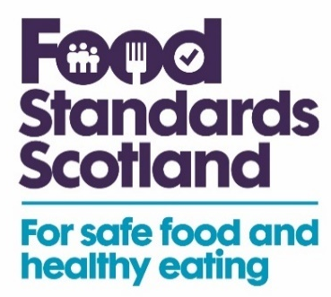


Eating healthier can feel like a bit of a challenge. From not having enough time to cook to shopping on a budget - it can be hard to know where to start.

The good news is that eating healthier can include a wide range of foods and Food Standards Scotland’s ‘Eat Well Your Way’ resource is designed to help you make small, manageable changes to your diet in a way that suits you.

You really don’t have to go to extreme lengths to eat healthier, just making little changes when planning, shopping and preparing food, as well as eating out, can make a difference to your overall health. So, for realistic ways to improve your diet, visit https://bit.ly/49p4ibf

